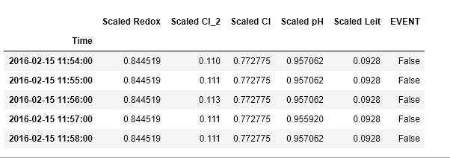

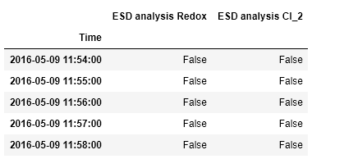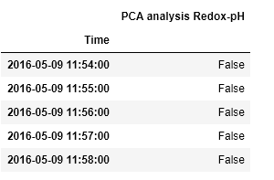

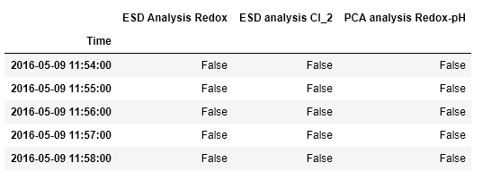

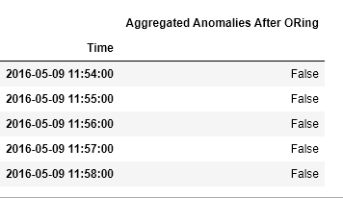

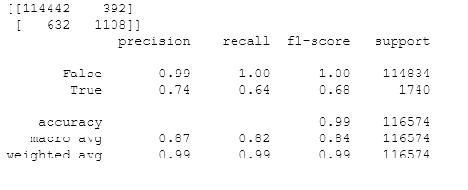

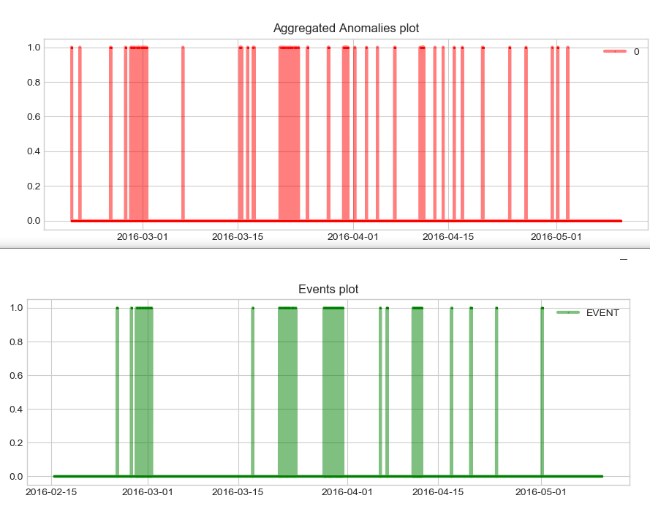

|  |  |  |  |  |  |  |  |  |
| --- | --- | --- | --- | --- | --- | --- | --- | --- |
| ***ALGORITHM*** | ***True Positive*** | ***True Negative*** | ***False***  ***Positive*** | ***False Negative*** | ***Precision True Events*** | ***Recall True Events*** | ***Accuracy*** | ***F1_score of True Events*** |
| ***PCA-ESD*** | **1108** | **114442** | **392** | **632** | **0.74** | **0.64** | **0.99** | **0.68** |
| ***ESD*** | **949** | **114442** | **392** | **791** | **0.71** | **0.55** | **0.99** | **0.62** |
| ***PCA*** | **265** | **114834** | **0** | **1475** | **0.1** | **0.15** | **0.99** | **0.26** |